Testing Scripts Outputs.
MDM Transport/DmWapPush not Running:
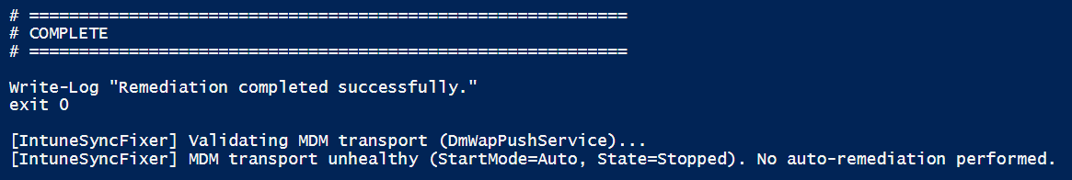
MDM Transport/DmWapPush Running:
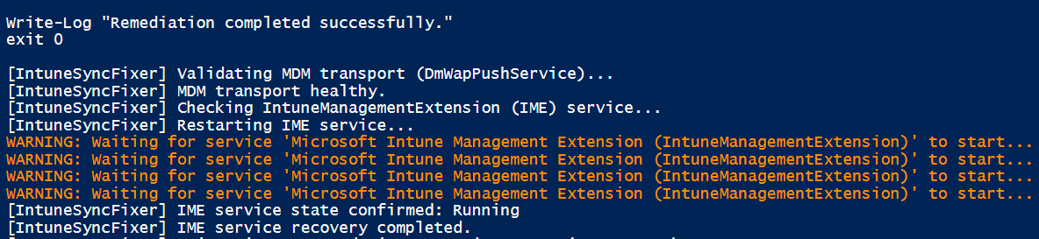

Registry:
[HKEY_LOCAL_MACHINE\software\microsoft\intunemanagementextension\SideCarPolicies\Scripts\Reports\ca739d87-e611-4144-acd7-94b08a51c5bb]
[HKEY_LOCAL_MACHINE\software\microsoft\intunemanagementextension\SideCarPolicies\Scripts\Reports\ca739d87-e611-4144-acd7-94b08a51c5bb\f6fe8f65-0851-4321-8eb0-327c4a9142f4_1\Result]
"Result"="{"PolicyId":"f6fe8f65-0851-4321-8eb0-327c4a9142f4","UserId":"ca739d87-e611-4144-acd7-94b08a51c5bb","PolicyHash":null,"Result":3,"ResultDetails":"{\"Version\":1,\"SigningCode\":649,\"EncryptionCode\":633,\"SigningMsg\":\"(Success) AccountId:7717fc5e-ac03-4e03-93a7-9adaeddac486,PolicyId:f6fe8f65-0851-4321-8eb0-327c4a9142f4,Type:6,Enforce: Enforcement2. OSVersion:10.0.26100,AgentVersion:1.97.107.0. \",\"EncryptMsg\":\"run in legacy mode\"}","InternalVersion":1,"ErrorCode":0,"ResultType":1,"PreRemediationDetectScriptOutput":"Last IME activity: AgentExecutor.log (0h ago)","PreRemediationDetectScriptError":"","RemediationScriptErrorDetails":null,"RemediationScriptOutputDetails":null,"PostRemediationDetectScriptOutput":null,"PostRemediationDetectScriptError":null,"RemediationStatus":4,"Info":{"RemediationExitCode":null,"FirstDetectExitCode":0,"LastDetectExitCode":null,"ErrorDetails":null},"TargetType":1,"RunAsAccount":2,"AssignmentFilterIds":["00000000-0000-0000-0000-000000000000"],"BiosMetadata":null,"IsFullSync":false}"

Technical Summary – IME Registry Reporting
The registry data under
HKLM\Software\Microsoft\IntuneManagementExtension\SideCarPolicies\Scripts\Reports
confirms successful reporting of the proactive remediation policy f6fe8f65-0851-4321-8eb0-327c4a9142f4 for user ca739d87-e611-4144-acd7-94b08a51c5bb.
The LastFullReportTimeUTC value indicates that IME completed a full status report upload to the Intune service at 02-02-2026 09:24:00 (UTC). The stored execution result shows an overall Success (Result = 3) with ErrorCode = 0.
Detection completed successfully with a FirstDetectExitCode of 0, confirming the device was compliant. As no issue was detected, remediation did not execute (RemediationStatus = 4). No remediation output or error details are present, which is expected for a compliant evaluation.
Script integrity checks passed successfully (SigningCode = 649) and the script executed using legacy PowerShell execution mode (EncryptionCode = 633). The policy was processed as a user-targeted assignment while running under the SYSTEM account context.

HealthScript
<![LOG[[HS] new result = {"PolicyId":"f6fe8f65-0851-4321-8eb0-327c4a9142f4","UserId":"ca739d87-e611-4144-acd7-94b08a51c5bb","PolicyHash":null,"Result":3,"ResultDetails":"{\"Version\":1,\"SigningCode\":649,\"EncryptionCode\":633,\"SigningMsg\":\"(Success) AccountId:7717fc5e-ac03-4e03-93a7-9adaeddac486,PolicyId:f6fe8f65-0851-4321-8eb0-327c4a9142f4,Type:6,Enforce: Enforcement2. OSVersion:10.0.26100,AgentVersion:1.97.107.0. \",\"EncryptMsg\":\"run in legacy mode\"}","InternalVersion":1,"ErrorCode":0,"ResultType":1,"PreRemediationDetectScriptOutput":"Last IME activity: AgentExecutor.log (0h ago)","PreRemediationDetectScriptError":"","RemediationScriptErrorDetails":null,"RemediationScriptOutputDetails":null,"PostRemediationDetectScriptOutput":null,"PostRemediationDetectScriptError":null,"RemediationStatus":4,"Info":{"RemediationExitCode":null,"FirstDetectExitCode":0,"LastDetectExitCode":null,"ErrorDetails":null},"TargetType":1,"RunAsAccount":2,"AssignmentFilterIds":["00000000-0000-0000-0000-000000000000"],"BiosMetadata":null,"IsFullSync":false}]LOG]!><time="14:55:45.6453322" date="2-2-2026" component="HealthScripts" context="" type="1" thread="74" file="">
<![LOG[[HS] script result (id = f6fe8f65-0851-4321-8eb0-327c4a9142f4, version = 1) is different from cached one, save to cache.]LOG]!><time="14:55:45.6453322" date="2-2-2026" component="HealthScripts" context="" type="1" thread="74" file="">
<![LOG[[HS] Saving policy results for user: ca739d87-e611-4144-acd7-94b08a51c5bb]LOG]!><time="14:55:45.6453322" date="2-2-2026" component="HealthScripts" context="" type="2" thread="74" file="">
<![LOG[[HS] Runner ..................... Completed user session 2, userId: ca739d87-e611-4144-acd7-94b08a51c5bb, userSID: ..................... ]LOG]!><time="14:55:45.6610300" date="2-2-2026" component="HealthScripts" context="" type="2" thread="74" file="">
<![LOG[[HS] Load 1 user keys under execution.]LOG]!><time="14:55:45.6610300" date="2-2-2026" component="HealthScripts" context="" type="1" thread="74" file="">
<![LOG[[HS] inspect hourly schedule for policy f6fe8f65-0851-4321-8eb0-327c4a9142f4: UTC = False, Interval = 1, Time = ]LOG]!><time="14:55:45.6610300" date="2-2-2026" component="HealthScripts" context="" type="1" thread="74" file="">
<![LOG[[HS] Calcuated earliest time is 02-02-2026 10:25:45]LOG]!><time="14:55:45.6610300" date="2-2-2026" component="HealthScripts" context="" type="1" thread="74" file="">
<![LOG[[HS] Runner : queued time : 02-02-2026 09:23:59 is expired.., clear the queue]LOG]!><time="14:55:45.6610300" date="2-2-2026" component="HealthScripts" context="" type="2" thread="74" file="">
<![LOG[[HS] Runner : Job is queued and will be scheduled to run at UTC 02-02-2026 10:25:45.]LOG]!><time="14:55:45.6610300" date="2-2-2026" component="HealthScripts" context="" type="1" thread="74" file="">

Technical Summary – Intune Proactive Remediation Execution
The Intune Management Extension (IME) HealthScripts engine successfully executed the proactive remediation policy f6fe8f65-0851-4321-8eb0-327c4a9142f4 for user ca739d87-e611-4144-acd7-94b08a51c5bb.
The detection script completed with exit code 0, indicating the device was compliant. As no issue was detected, remediation was not required (RemediationStatus = 4). The overall execution result was reported as Success (Result = 3) with ErrorCode = 0.
Script signature validation and encryption checks completed successfully (SigningCode = 649, EncryptionCode = 633). The script executed under the SYSTEM context for a user-targeted assignment, using legacy PowerShell execution mode.

Agent Executor
<![LOG[Prepare to run Powershell Script ..]LOG]!><time="14:54:05.8524421" date="2-2-2026" component="AgentExecutor" context="" type="1" thread="1" file="">
<![LOG[cmd line for running powershell is -NoProfile -executionPolicy bypass -file "C:\WINDOWS\IMECache\HealthScripts\f6fe8f65-0851-4321-8eb0-327c4a9142f4_1\detect.ps1" <ScriptParams not logged for remediation scripts>]LOG]!><time="14:54:05.8524421" date="2-2-2026" component="AgentExecutor" context="" type="1" thread="1" file="">
<![LOG[PowerShell path is C:\Windows\SysWOW64\WindowsPowerShell\v1.0\powershell.exe]LOG]!><time="14:54:05.8524421" date="2-2-2026" component="AgentExecutor" context="" type="1" thread="1" file="">
<![LOG[[Executor] created powershell with process id 14628]LOG]!><time="14:54:05.9105968" date="2-2-2026" component="AgentExecutor" context="" type="1" thread="1" file="">
<![LOG[Powershell exit code is 0]LOG]!><time="14:54:18.9184448" date="2-2-2026" component="AgentExecutor" context="" type="1" thread="1" file="">
<![LOG[length of out=86]LOG]!><time="14:54:18.9204700" date="2-2-2026" component="AgentExecutor" context="" type="1" thread="1" file="">
<![LOG[length of error=2]LOG]!><time="14:54:18.9204700" date="2-2-2026" component="AgentExecutor" context="" type="1" thread="1" file="">
<![LOG[error from script =
]LOG]!><time="14:54:18.9204700" date="2-2-2026" component="AgentExecutor" context="" type="1" thread="1" file="">
<![LOG[Powershell script is successfully executed.]LOG]!><time="14:54:18.9222392" date="2-2-2026" component="AgentExecutor" context="" type="1" thread="1" file="">
<![LOG[write output done. output = Healthy | Intune transport + IME OK
Last IME activity: AgentExecutor.log (0h ago)

Technical Summary – IME AgentExecutor Script Execution

The Intune Management Extension (IME) AgentExecutor component initiated execution of the detection script detect.ps1 associated with proactive remediation policy f6fe8f65-0851-4321-8eb0-327c4a9142f4.

The script was launched using Windows PowerShell (v1.0) from the SysWOW64 path, indicating 32-bit legacy PowerShell execution.

PowerShell was invoked with the parameters -NoProfile and -ExecutionPolicy Bypass, ensuring no user profile loading and bypass of local execution policy restrictions. The script was executed from the IME cache directory:
C:\Windows\IMECache\HealthScripts\f6fe8f65-0851-4321-8eb0-327c4a9142f4_1\detect.ps1

A PowerShell process was successfully created (PID 14628) and completed execution with an exit code of 0, indicating successful detection and a compliant state. Script standard output was captured successfully (86 characters), while the error stream contained no meaningful content despite a minimal buffer allocation (length = 2), and no script errors were logged.

The script completed execution successfully and returned the following detection output to IME:

Healthy | Intune transport + IME OK
Last IME activity: AgentExecutor.log (0h ago)

This output was written to the IME reporting pipeline and later surfaced in the HealthScripts result data. No execution, runtime, or PowerShell host errors were observed.

